Documentation

1. Navbar and footer



Fixed Navbar with 5 links that lead to about us page, gallery page, community page, submission page, and also the logo on the left as a button for the home page.

When less than 768px in width, the navbar changes to accommodate the smaller size by using a hamburger toggle button.  
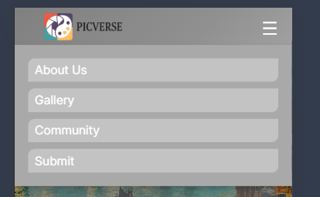

Reference : <https://www.novelupdates.com/>



It contains only 3 links to about us page, submission page and community page.

Reference :

<https://www.voguebusiness.com/>

<https://www.makeup.com/>

1. Home Page

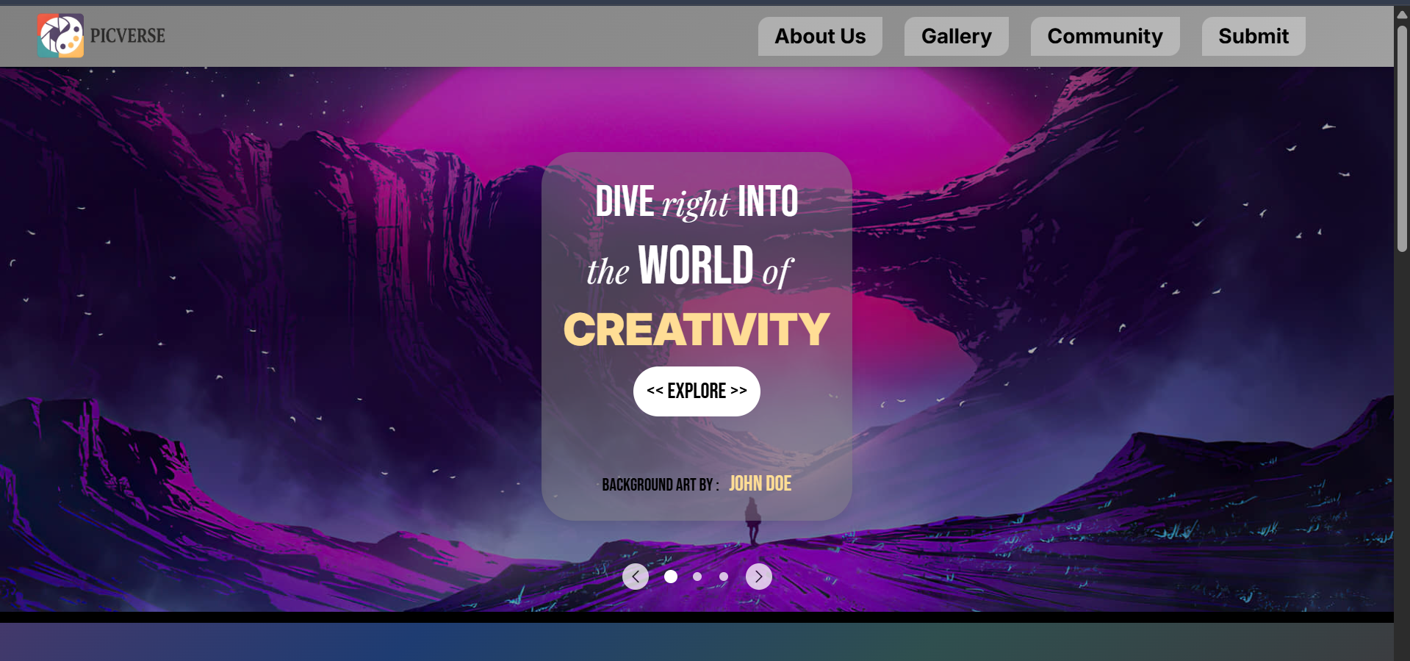

A hero slider that switches every 5 seconds and can also be changed manually with the buttons on the bottom half of the slide. Manual change resets automatic timer.

Reference : <https://www.sliderrevolution.com/>



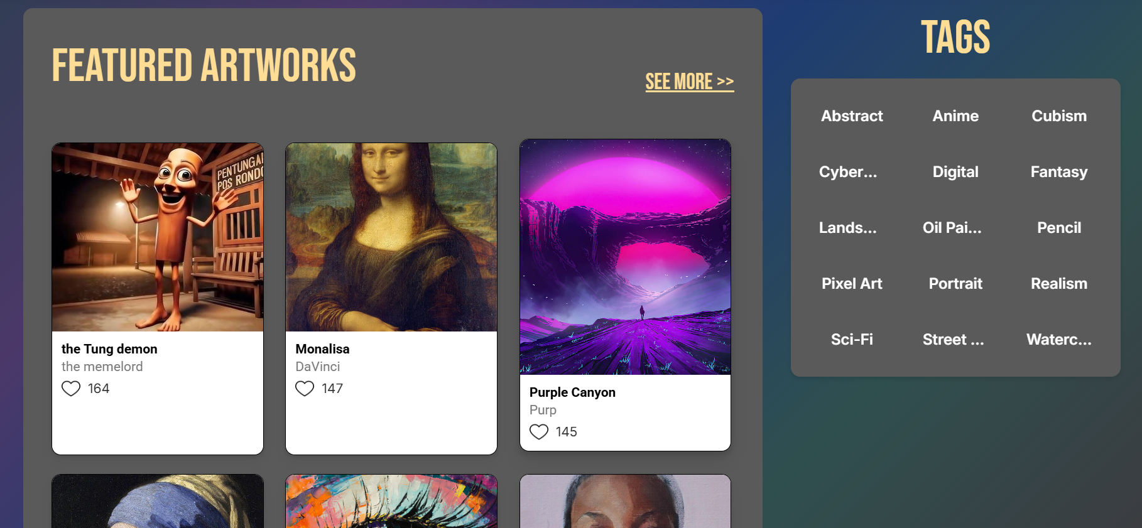

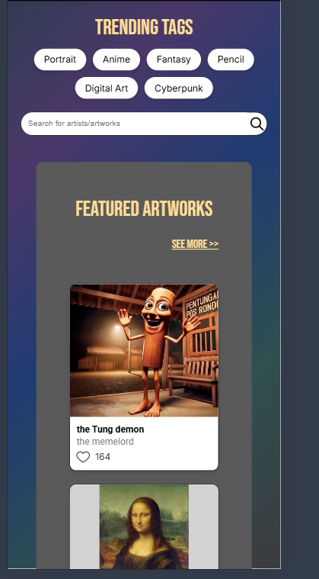

Changes to one column.

Reference : <https://aniwatchtv.to/home>

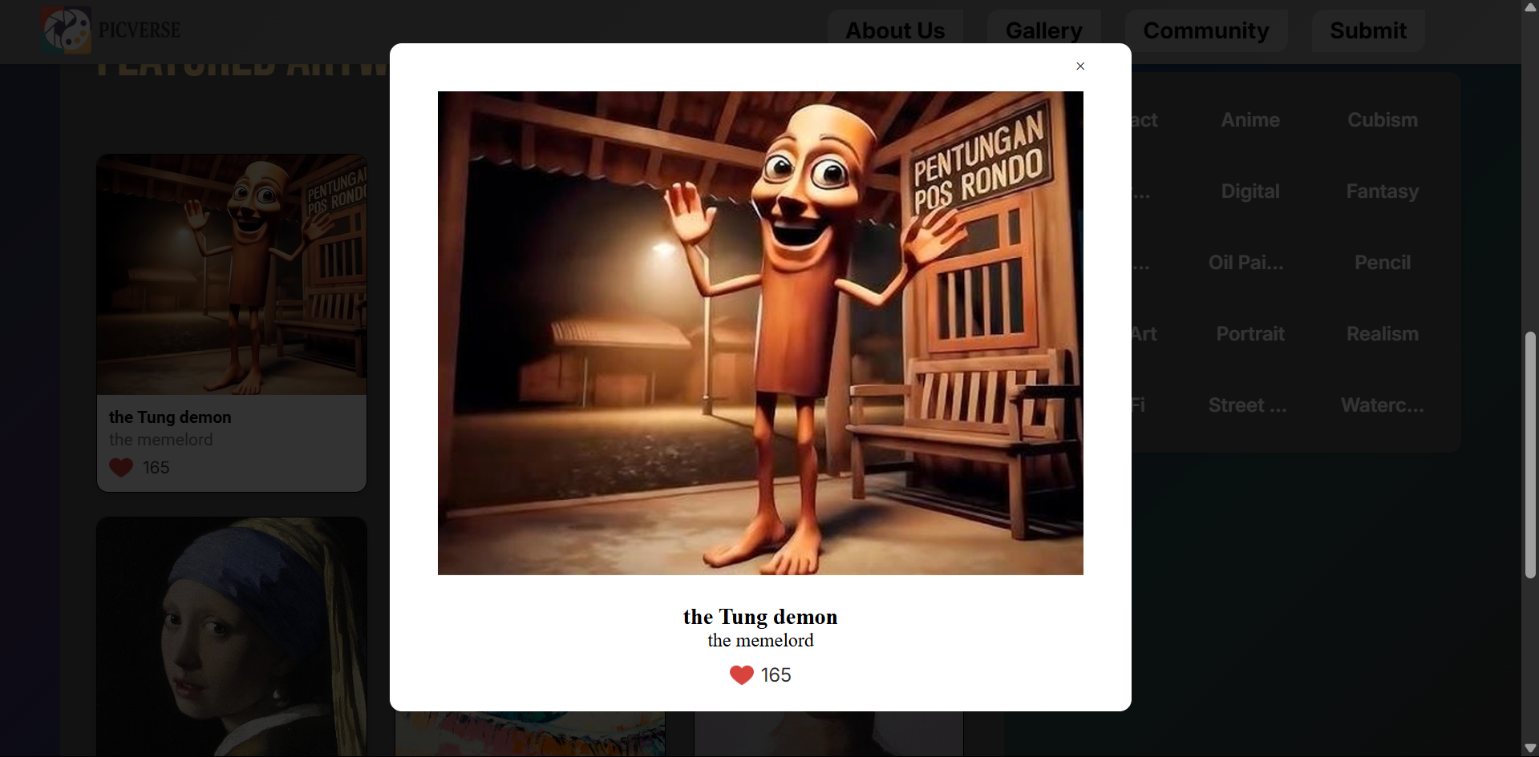

Popup for artcard. Also present in gallery page

1. Gallery Page

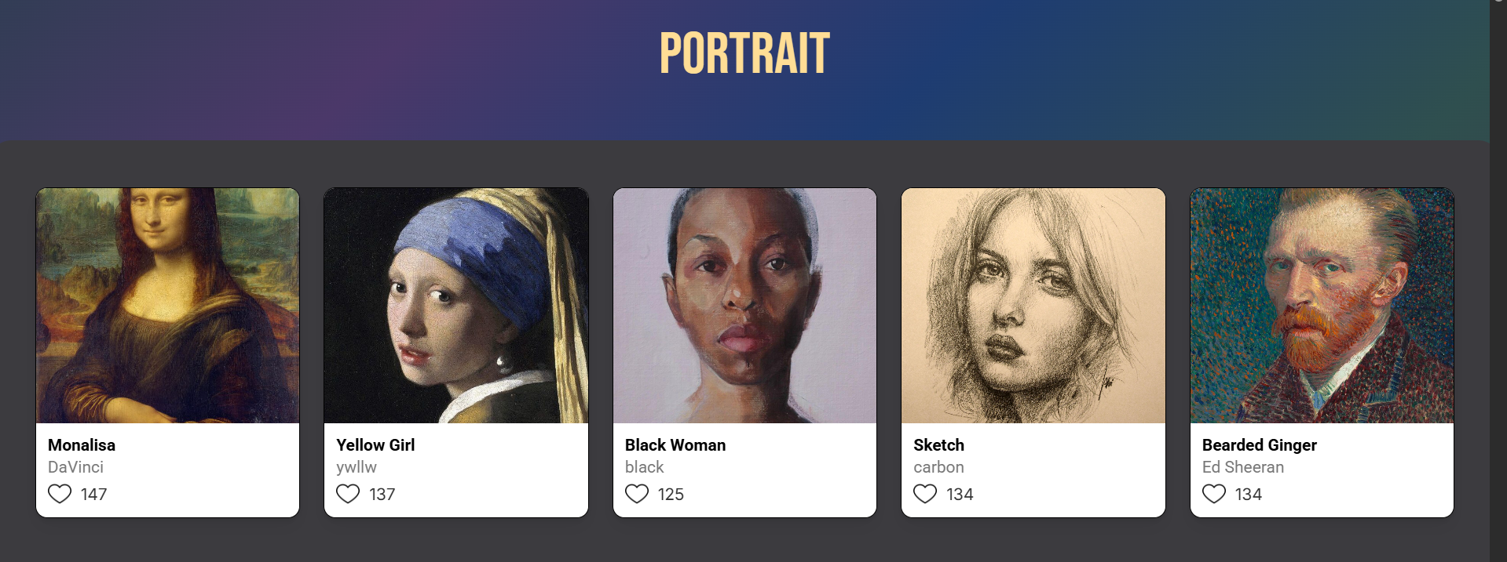

This is an example for one tag and 5 pictures related to it. Each tag has this.

Reference : <https://aniwatchtv.to/home>

1. About Us Page

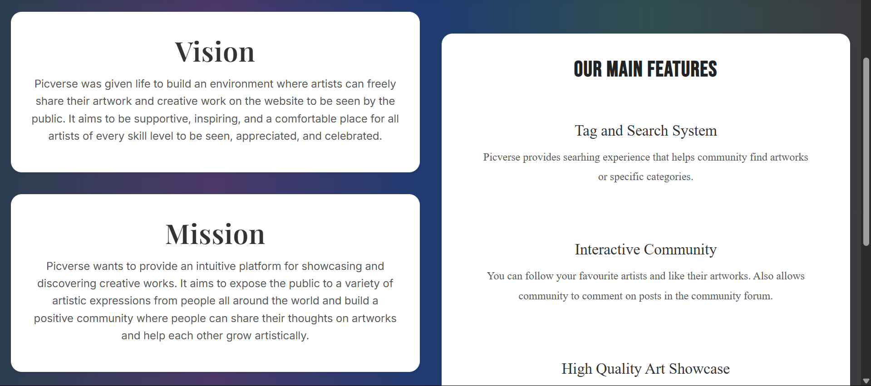

Arranged slightly differently from reference but the idea was from : <https://id.pinterest.com/pin/844493673249431/>

1. Community Page

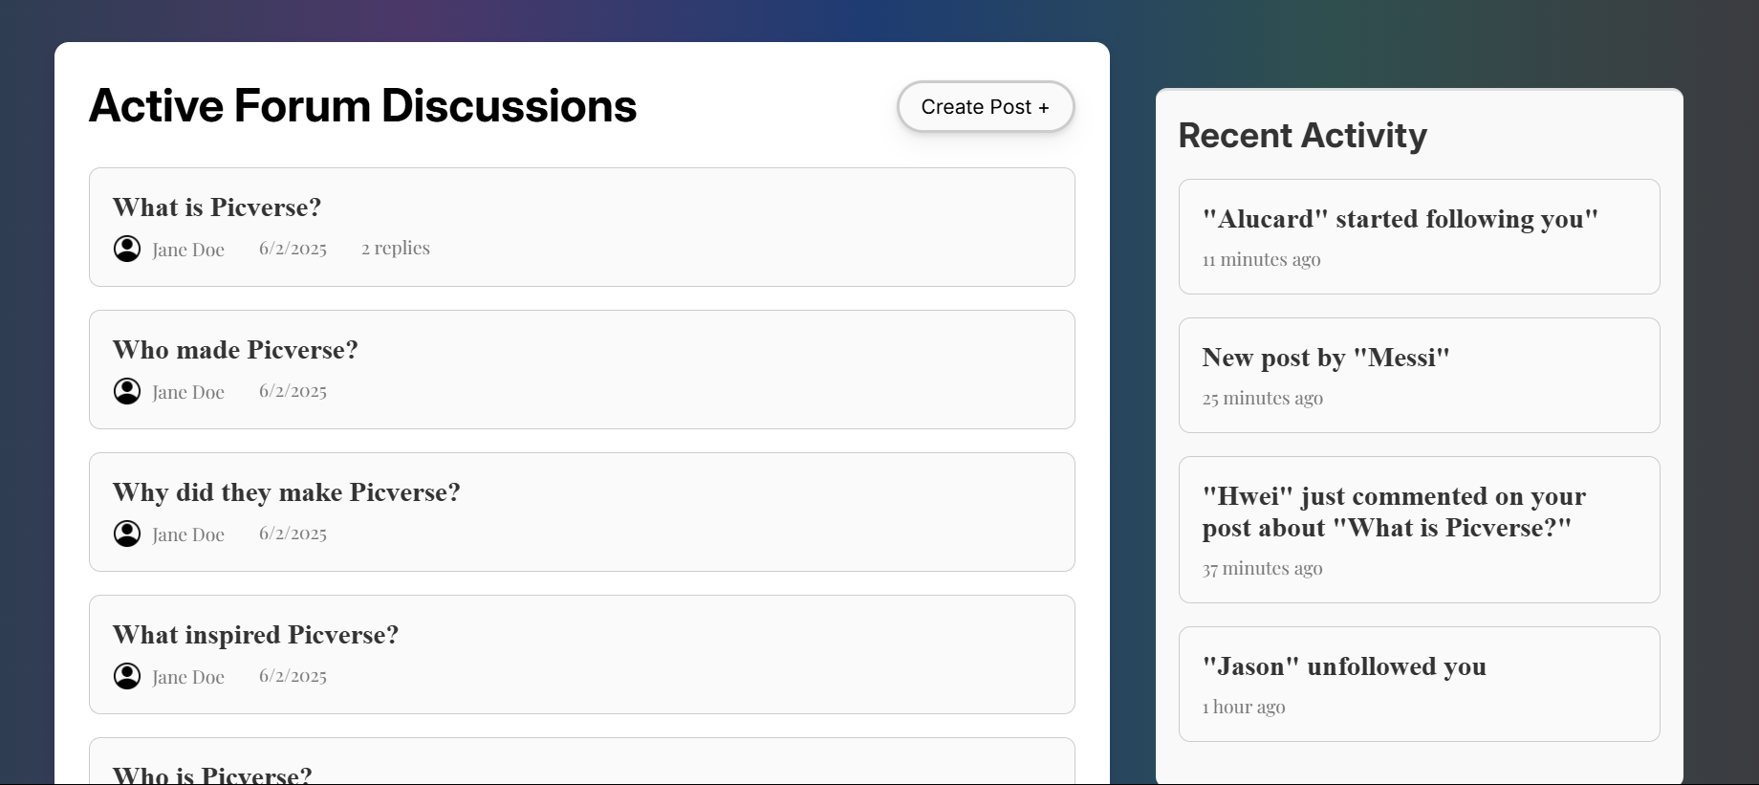

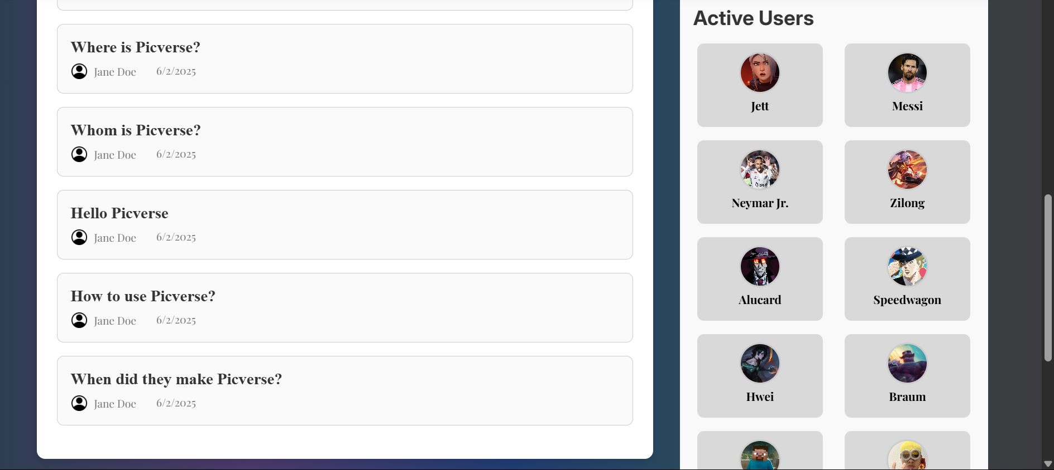

Create post button shows a popup

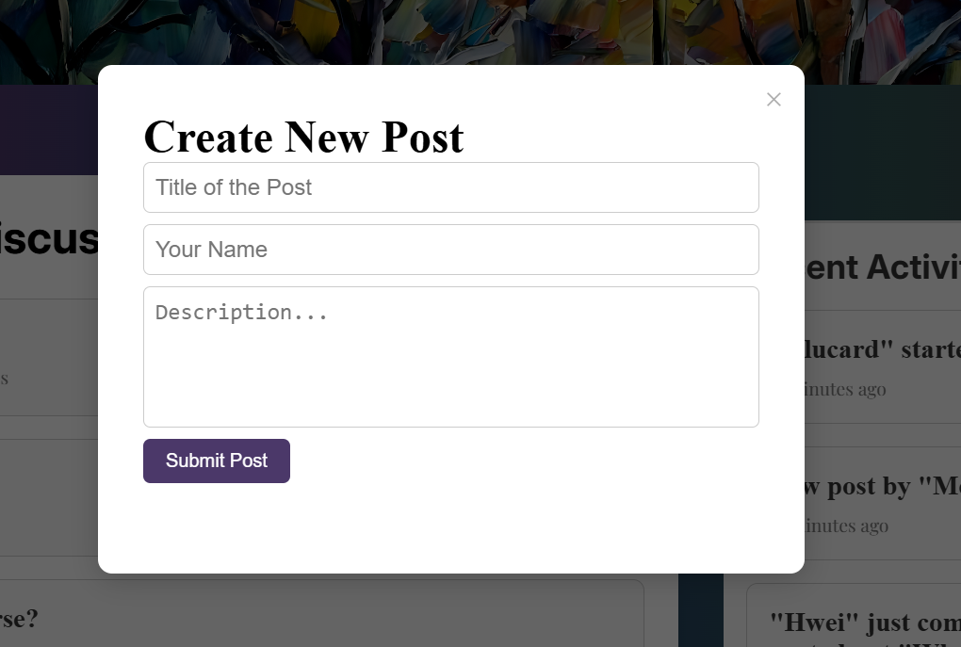

Active forum on the left while the right side contains recent activity and active users.

Reference :

<https://aniwatchtv.to/community/board>

<https://www.fandom.com/>

1. Submit Page

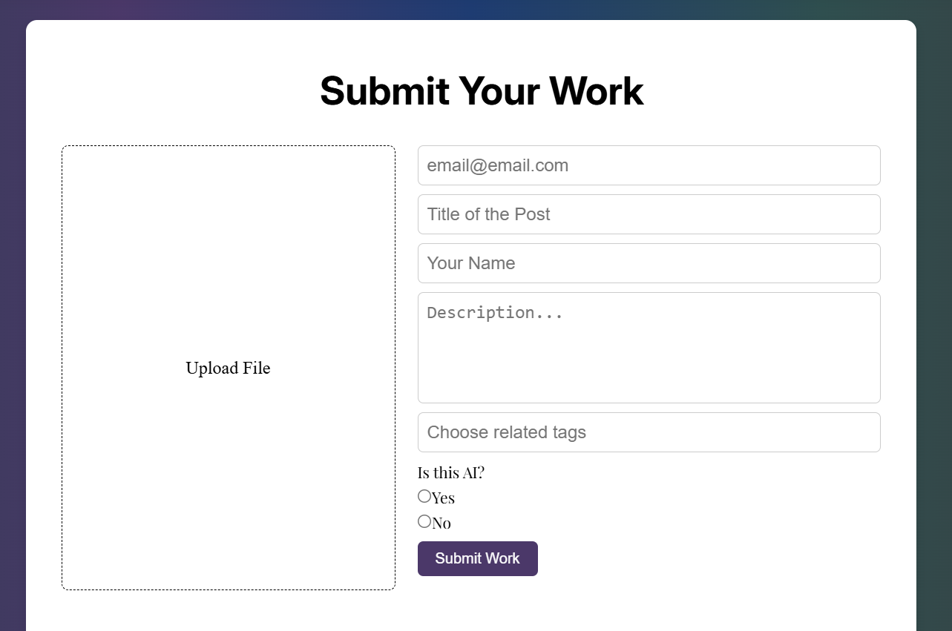

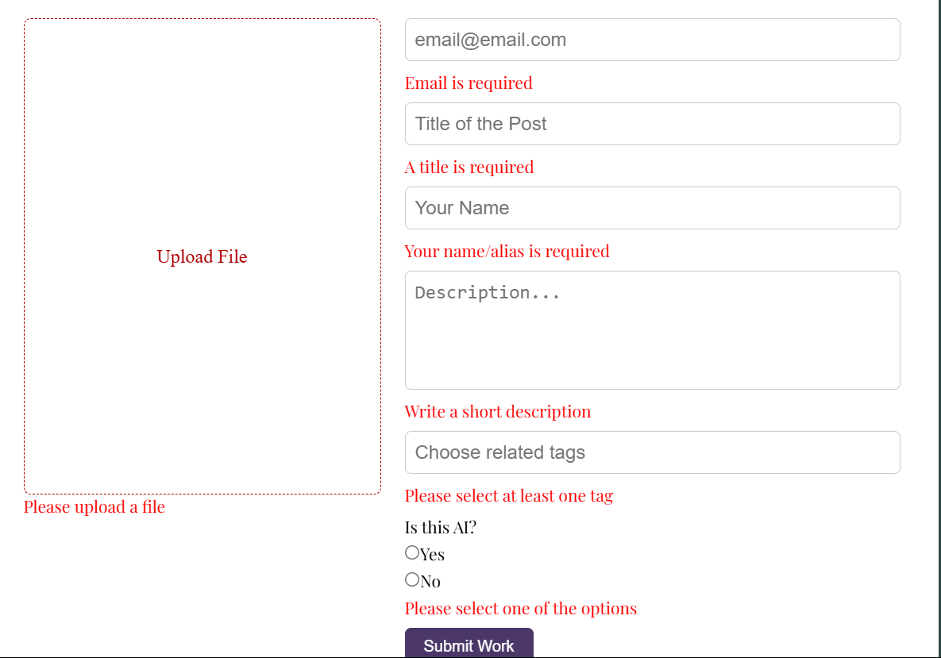

Reference:

<https://youtube.com/shorts/HrOrQ-U9BY8?si=LoajAOZYCeG-pZ-C>

<https://docs.workato.com/assets/img/page-template-submission-form.01402eeb.png>